**4 February 2019**

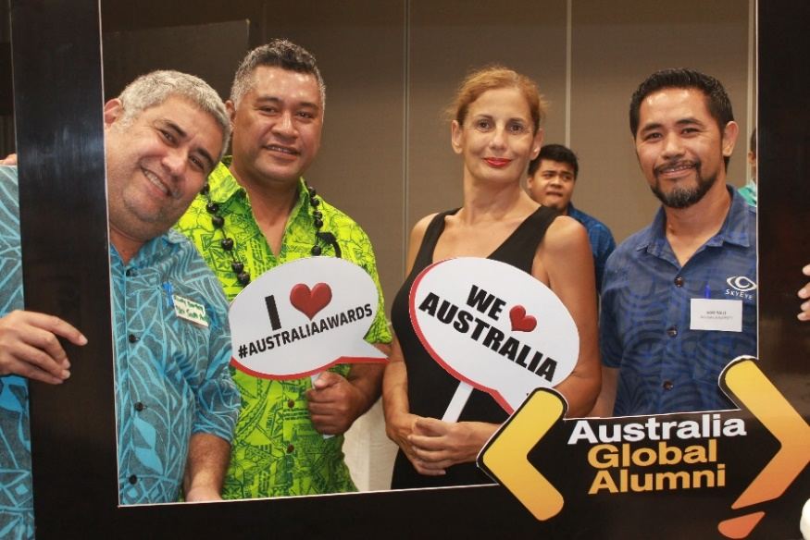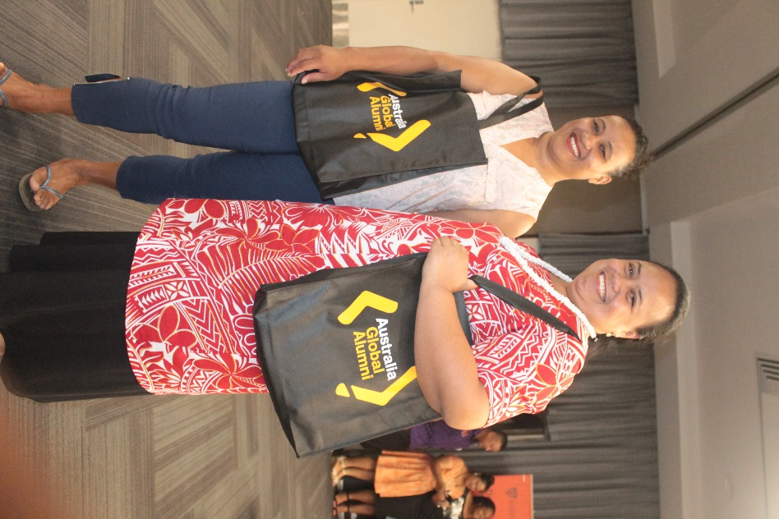

March 2018: Past pupils of the Australia Awards program attending the Education Roadshow 2018.

**AUSTRALIAN SCHOLARSHIPS ACCEPTING APPLICATIONS FOR 2020**

THE Australian High Commission is pleased to announce that the Australia and Samoa Government Overseas Scholarships for next year (2020) are now open, with the deadline for submissions at 4:00 pm, Thursday 14th of March 2019.

Samoan citizens are invited to apply for the Open Category Scholarships for full-time on campus studies, or part-time Distance and Flexible Learning (DFL). Studies are offered at institutions in Australia, the region and via DFL. The awards are offered to citizens who are currently employed in the public or private sector. Priority is given to studies who meet National Human Resource Development priority needs, and to those applicants who are able to demonstrate leadership ability and potential.

Australian High Commissioner HE Sara Moriarty acknowledged the scholarship tripartite agreement between the Governments of Samoa, Australia and New Zealand.

“This harmonised scholarship program between the Government of Samoa, Australia and New Zealand would not be possible without the Government of Samoa’s leadership and partnership in driving the scholarships platform,” Ms Moriarty said.

“Australia is pleased to build on an enduring partnership with Samoa through the provision of short and long term scholarships for Samoan citizens with an opportunity to study in Australia, the region, and locally through DFL.”

“On behalf of the Australia Government, we hope the synchronisation of scholarships, which has been ongoing for several years, will promote more efficient and effective use of all our resources.”

“Tertiary education is an important investment for the future and these scholarships provide the next generation of global leaders with an opportunity to study abroad or online with an Australian Institution and then return home with newfound knowledge that we hope will greatly contribute to the development of Samoa, and build invaluable people to people links and trust between our nations,” Ms Moriarty concluded.

A total of 56 Australian scholarships were announced for 2019 intake. Scholars will undertake study in a variety of industries including engineering, biomedical science, cybersecurity, education, management and business, medical laboratory and hospitality management.

**Scholarship Eligibility Details:**

NZ Open category Awards will be advertised separately. NUS Foundation Level students are not eligible to apply.

1. Applicant must request a new course of study and not seek support for a course already commenced.
2. Applicant must be applying for an upgrade of their highest qualification.
3. Categories of Study: Undergraduate studies, on campus Post Graduate, Distance Flexi Education (conditions apply).
4. Applicants wishing to apply for onsite studies must apply online. The online portal will open on 4th February 2019. Link for the online form : https://oasis.dfat.gov.au
5. Applicants wishing to apply for studies via distance and flexible learning should download forms from the MFAT website [www.mfat.gov.ws](http://www.mfat.gov.ws)
6. Samoan citizens holding citizenship of any other developed country (including American Samoa/USA, Australia) are ineligible to apply for Australia or New Zealand Government funded Awards. These citizens are eligible to apply for the Government of Samoa (DFL) Awards (GOS covers 95% of tuition fees plus book allowance).
7. Must be currently employed and have worked in Samoa for more than 2 years.
8. Must be residing in Samoa / have resided for a minimum of 2 consecutive years at the time of application.
9. Must sign a Government Scholarship Bond prior to departure for study.
10. Applicants must have a valid email address in order to receive notifications on the status of their application.

For more information, contact the **Bilateral Relations Division, Ministry of Foreign Affairs and Trade (MFAT), Level 3, FMFM II Government Building.** Tel: 21171 / 22856.

The deadline for submission of all completed forms is 4:00 pm Thursday 14th March 2019.

**ENDS**