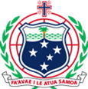
Ministry of Health
Coronavirus (COVID-19) Update
19/03/2020

SAMPLE TESTING CLARIFCATION

Due to the urgency of the request from the Ministry of Health, (MoH) we have been advised by laboratories in both Australia and New Zealand, that the turnaround time for testing samples from Samoa will be between 3 to 5 days.

Please check our website and facebook pages for updates and latest travel advisory. Ministry of Health Website: www.health.gov.ws
Government of Samoa Website www.samoagovt.ws
They same information are also available on Facebook
FB: @samoagovt @publichealthsamoa

