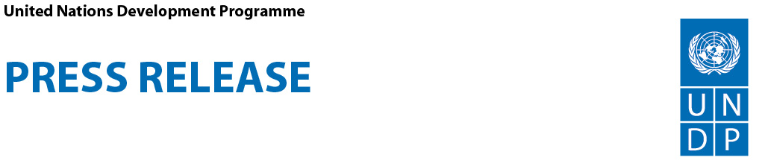

COVID-19: Samoa Parliament to continue crucial functions despite pandemic, thanks to over USD$100,000 video-conferencing solutions

Apia, Samoa (Tuesday 21 April 2020) – The Legislative Assembly of Samoa in responding to the COVID-19 pandemic, has risen to the challenge by quickly adapting the way it is conducting its business and moving part of its work online with support from the United Nations Development Programme (UNDP).

With the COVID-19 pandemic, many Parliaments across the Pacific and globally are struggling with the challenge to fulfil their democratic mandate and ensure governmental accountability, while at the same time practicing physical distancing and basic hygiene measures.

Along with a few other innovative Parliaments around the world, the Legislative Assembly of Samoa has adopted processes and mechanisms to ensure that they can work online, using information and communication technologies.

This critical initiative, which allows remote working of Members of Parliament and parliamentary staff as well as virtual parliamentary committee meetings, is supported by UNDP’s Strengthening Legislatures in the Pacific Island Countries (SLIP) Project, funded by the Government of Japan.

Speaking at the official handover ceremony, the Resident Representative for the UNDP Samoa Office, Jorn Sorensen, highlighted the importance for parliaments to continue to carry out their legislative, oversight and representative functions within the safety measures outlined for the prevention of the spread of COVID-19.

“At UNDP, we recognize that the role of Parliament in a time of crisis is more vital than ever to pass and review emergency laws, allocate and scrutinize the use of public resources as well as oversee government’s action,” said Sorensen.

“This brings us to the reason we are gathered this morning at this handover ceremony. Today, UNDP’s SLIP Project has committed to assist the Legislative Assembly of Samoa with ICT equipment worth a little over 300,000 Samoan Tālā (over US$105,000), to ensure that parliamentary committees continue to fulfil their crucial role in reviewing bills, overseeing government’s policies and representing the citizens’ interests.”

He added, “The ICT equipment will enable remote working of parliamentary staff and members of Parliament, including sittings of parliamentary committees in line with the Samoan Government’s physical distancing measures.”

In receiving the ICT Equipment on behalf of the Legislative Assembly of Samoa, the Speaker of Parliament, Hon. Leaupepe Toleafoa Fa’afisi, expressed his gratitude and affirmed the crucial support these new equipment will accord to Members of Parliament and their constituents.

“This initiative is quite an achievement for the Parliament of Samoa which will enable our Parliamentary Committees to conduct meetings via teleconferencing and to receive online public submissions,” said Leaupepe.

“Furthermore, this initiative has enabled Parliamentarians to be better equipped in carrying out their duties and responsibilities in an advanced and professional way. It will also assist our Parliamentary Committees in engaging and collecting more feedback from outer districts and communities.”

The Ambassador of Japan to Samoa, H. E. Mr Terasawa Genichi, in his speech, highlighted the importance of Parliament in delivering effective and efficient service in the national decision-making process.

“It is quite fitting that given the current global health crisis with the COVID-19 pandemic and the Government’s lockdown, this equipment and the use of technology will enable a much easier telework communication and save costs in the future for the Parliament,” said Genichi.

He added, “Japan is confident of UNDP’s knowledge and expertise in implementing this project with the best standards and successful results.”

The support provided by UNDP through the “Strengthening Legislatures in the Pacific Island Countries Project”, funded by the Government of Japan, focuses on strengthening the Parliaments of six Pacific Island countries to become more effective, efficient, inclusive and transparent. The project is implemented in the Federated States of Micronesia, Fiji, the Republic of Marshall Islands, Samoa, the Solomon Islands and Vanuatu.

The United Nations in the Pacific continues to support countries to set up a multisectoral whole-of-society approach to face the challenges beyond the health sector, to limit the spread of COVID-19 and to mitigate the potentially devastating impact it may have on vulnerable populations and economies.

### ### ###

For more information:
- Laufaleaina Lesa, Communications Analyst, UNDP Office in Samoa. E: laufaleaina.lesa@undp.org, Ph: (685) 23670 ext 12

- Jone Tuiipelehaki Raqauqau, Communications Associate – Effective Governance Team, UNDP Pacific Office in Fiji. E: jone.raqauqau@undp.org, M: (679) 7836 744

UNDP is the leading United Nations organization fighting to end the injustice of poverty, inequality, and climate change. Working with our broad network of experts and partners in 170 countries, we help nations to build integrated, lasting solutions for people and planet.
Learn more at undp.org or follow at @UNDP.

